PROTOCOL – RECRUITMENT OF EX-OFFENDERS

As an organisation using the DBS (Criminal Records Bureau) Disclosure service to assess applicants’ suitability for positions of trust, Vine Medical Group complies fully with the DBS (CRB) Code of Practice and undertakes to treat all applicants for positions fairly. It undertakes not to discriminate unfairly against any subject of a Disclosure on the basis of a conviction or other information revealed.

Vine Medical Group is committed to the fair treatment of its staff, potential staff or users of its services, regardless of race, gender, religion, sexual orientation, responsibilities for dependants, age, physical/mental disability or offending background.

This policy on the recruitment of ex-offenders is made available to all Disclosure applicants at the outset of the recruitment process.

We actively promote equality of opportunity for all with the right mix of talent, skills and potential and welcome applications from a wide range of candidates, including those with criminal records. We select all candidates for interview based on their skills, qualifications and experience.

A Disclosure is only requested after a thorough risk assessment has indicated that one is both proportionate and relevant to the position concerned. For those positions where a Disclosure is required, all application forms, job adverts and recruitment briefs will contain a statement that a Disclosure will be requested in the event of the individual being offered the position.

Where a Disclosure is to form part of the recruitment process, we encourage all applicants called for interview to provide details of their criminal record at an early stage in the application process. We request that this information is sent under separate, confidential cover, to a designated person within Vine Medical Group and we guarantee that this information will only be seen by those who need to see it as part of the recruitment process.

Unless the nature of the position allows Vine Medical Group to ask questions about your entire criminal record, we only ask about ‘unspent’ convictions as defined in the Rehabilitation of Offenders Act 1974.

We ensure that all those in Vine Medical Group who are involved in the recruitment process are able to identify and assess the relevance and circumstances of offences. We also ensure that they have access to appropriate guidance in interpreting the relevant legislation relating to the employment of ex-offenders, e.g. the Rehabilitation of Offenders Act 1974 (see Appendix 1 attached)

At interview, or in a separate discussion, we ensure that an open and measured discussion takes place on the subject of any offences or other matter that might be relevant to the position. Failure to reveal information that is directly relevant to the position sought could lead to withdrawal of an offer of employment.

We make every subject of a DBS (CRB) Disclosure aware of the existence of the DBS (CRB) Code of Practice and make a copy available on request.
We undertake to discuss any matter revealed in a Disclosure with the person seeking the position before withdrawing a conditional offer of employment.

Having a criminal record will not necessarily bar you from working with us. This will depend on the nature of the position and the circumstances and background of your offences. A key point to remember about all DBS certificates is that they do not issue a ‘pass or fail’ result. Their role is to provide Vine Medical Group as the employer with adequate and relevant information to support in making a safe recruitment decision and all it will do is show whether an individual has a criminal record, caution, warning or conviction.

If the check does show something, it might mean Vine Medical Group deems an applicant unsuitable for the role they’ve applied for. We always take into account the seriousness of the crime, when it took place and how relevant it is to the role before completely ruling a candidate out, however, under the Rehabilitation of Offenders Act 1974, we recognise that offenders must have a fair chance to apply for a role just like everybody else.

If, however, you were convicted for something to do with children and the role requires you to work directly with children, it is highly likely that Vine Medical Group would deem you unsuitable for the role.

Appendix 1

Factors to consider for a particular role:
How relevant an applicant’s criminal record is to the role they’ve applied for will vary depending on lots of things, including the responsibilities, tasks and circumstances of the work.
Please see below a number of questions that cover the types of considerations that we might want to give when deciding on the relevance of certain offences to a particular role.
Some of these might have been considered when determining what level of criminal record check should be carried out (i.e. basic or enhanced), however, the purpose of considering these questions again at this stage is to enable us to consider them in light of an applicant’s criminal record;

- What are the responsibilities of the role? (for example, the role may involve looking after cash)
- Are there any specific links between the responsibilities of the role and an opportunity for the applicant to re-offend in the workplace?
- Does the role involve direct contact with third-parties (customers or clients), or other colleagues, who are children or who are vulnerable? If so, how often would this happen and in what context? (for example, is there direct contact with children away from other adults, or is there only passive contact in open spaces?)
- What is the level of supervision that the person will receive? Are there significant parts of their role that are unsupervised? If so, what’s the nature of this unsupervised work? (e.g. depending on the level of supervision, a role working with children might be classed as ‘regulated activity’ and so a person barred from working with children would not be legally allowed to do it. However, they wouldn’t be prevented from roles that are not classed as ‘regulated activity’, such as working in a call centre or in a supermarket)
- What measures are in place to mitigate any particular concerns?
Factors to consider when assessing an individual’s criminal record

On the basis of the information that the applicant provides about their criminal record, both on the self-disclosure form and disclosure discussion, the following points need to be taken into account (this document hyperlink https://recruit.unlock.org.uk/knowledgebase/factors-to-consider/

- Relevance
- Nature
- Seriousness
- Pattern
- Age / time
- Circumstances at the time
- Attitude
- Changes in circumstances
- Why it’s being disclosed

Rehabilitation Periods in England and Wales

For all applications where the candidate currently resides in England and Wales the rehabilitation periods are as follows:

ADULTS – If you were 18 or over on the date of conviction
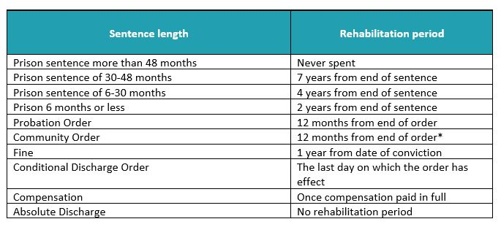
* Where the order does not specify the last day on which the order is to take effect, the rehabilitation period is 2 years from the date of conviction.

JUVENILES – If you were 17 or under on the date of conviction
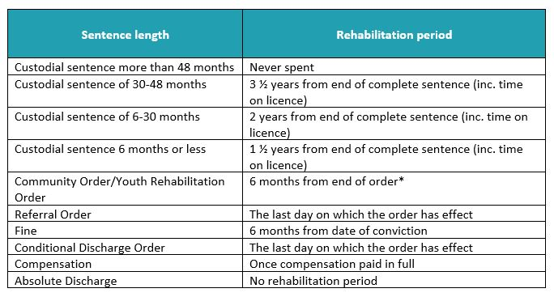
* Where the order does not specify the last day on which the order is to take effect, the rehabilitation period is 2 years from the date of conviction.

Frequently asked questions

Rehabilitation for Driving Offences
If you are convicted of a driving offence, such as speeding or drink driving, you will receive points on your licence and a possible driving ban.
These endorsements become spent after 5 years if you are over 18, or 2.5 years if you were under 18 at the time of the offence. However, these endorsements will stay on your licence for either 4 or 11 years, depending on the seriousness of the offence of which you were convicted.
If you fall within any of the exceptions, then you will be required to disclose all your convictions, both spent and unspent.
Applicants should always aim to give potential employers the full and accurate truth regarding their history, education and criminal record as an Enhanced Background

What is a DBS Check/Employment Background Check?
A DBS check looks at the record of a person’s past, specifically at any convictions, cautions, reprimands and warnings they may have received. In some instances, the DBS run checks against the adult and children’s barred list, depending on the role of an individual or the job for which they are applying.

What is an Enhanced DBS Check?
The enhanced check is the only check which provides information on those who may be included on the two DBS ‘barred lists’ (previously called ISA barred lists). It is a criminal oﬀence for those professionals on the barred list to be able to work with vulnerable adults and young children.

Good practice tips

- Deal with each individual on a case-by-case basis: No two individuals have exactly the same criminal record and circumstances. Avoid banning specific categories of offences.
- Tailor your approach: Don’t have a long list of irrelevant questions. Ask questions that you think might help you to better deal with the concerns you have.
- It’s up to you: Very few people are banned from working with children and/or vulnerable adults.
- Dates: Take into account the fact that the conviction date can often be much later than when the offence was committed.
- Assess: Focus on the concerns you have and consider what measures you can put in place to mitigate these.
- Get support: If somebody is on licence, or being supervised in the community, there may be a role for their probation officer to assist in providing further information.
Further references:

https://www.ucheck.co.uk/dbs-check-myths/

The Rehabilitation of Offenders Act 1974 (Exceptions) Order 1975

https://cbscreening.co.uk/news/post/convictionsdbscheck/

Appendix 2

MODEL DBS CHECK RISK ASSESSMENT

Guidance notes
This form can be used to assist in assessing and recording the risks of allowing someone to start work or volunteer in the setting prior to a DBS (Disclosure and Barring Service) check being received or where a DBS certificate shows relevant convictions or other relevant information. It is therefore important that it is fully completed and includes evidence rather than a series of statements.
The assessment of risk must be undertaken in accordance with the Policy on Recruitment of Ex-Offenders and Disclosure and Barring Service (DBS) checks.
The completion of this risk assessment form is the responsibility of the appointing manager or line manager as appropriate. This completed risk assessment form must be placed on the individual’s personnel file or other appropriate file and made available for Safeguarding and CQC inspections.
People may only work without a DBS in these circumstances when the following applies:
• The appointment is necessary to allow the service provision to continue.
• In the case of children, the person has an enhanced DBS certificate issued within the past 12 months by another body and the person provides the original enhanced DBS certificate to the appointing manager as evidence.
• An enhanced, DBS check has been applied for by the setting.
• This risk assessment and risk management plan has been completed and signed off by the relevant manager.

Name of applicant
Position Applied for
Disclosure Type (basic or enhanced)
Previous DBS Certificate number
Previous DBS Certificate date
Manager undertaking risk assessment

Section A – to be completed during the discussion between the recruiting manager and the applicant

Question | Applicable  (Yes/No/NA) | Evidence to support the decision
Did the applicant declare the offences/convictions on the application form and/or at the interview?
Did the applicant agree that the information on the previous DBS check was correct?
How did the applicant regard the offence/conviction with hindsight and what is their view towards the matter now.  Did the applicant demonstrate any efforts not to reoffend, e.g. rehabilitation course? | Applicant to explain.
Have the applicant’s circumstances changed since the offence, e.g. location, partner, family, education?
Is the applicant stating any mitigating circumstances e.g. peer pressure, financial problems or poor judgment due to external influence
Did the offences/convictions show any pattern, e.g. is there a history of reoccurrence or repeat offences?

Declaration by individual and any additional comments in support of their employment

I understand that any offer of employment will be subject to the information I have supplied and that this is complete and correct.
False information, or a failure to supply the details required could result in disciplinary action being taken.

Signature……………………………………………………………………..

Date……………………………………..

Print name……………………………………………………………………

Section B – Post-interview checks
Known information:
Have all the following checks been satisfactorily completed?
Photographic ID check Essential □
Verification of current address Essential □
Barred list check Essential □
Right to work in the UK Essential □
Confirmation of qualifications Essential □
Two references Essential □
Are they currently on the NHSE Performers List? Essential □
Are they known to the Deanery? Essential □

Section C – Authorisation
Decision – this is based on the ‘Known Information’ above.
□ High Risk – Person should NOT be allowed to start without a new Enhanced DBS as there has been a break in service for > 3 months, or there has not been a previous Enhanced DBS check and/or there is insufficient information about the candidate in the ‘Known information’ above.
□ Low Risk – Person may start work as they already hold an Enhanced DBS check from a previous role and there is no break in service of >3 months or more and all other checks have been satisfactorily completed.

Outcome: Agreement to continue with offer OR withdraw offer based on evidence supplied

Name:

Signature:

