New Patient Registration Form Please complete all pages in full using BLOCK capitals

1. Background Details
Contact Details
NHS Number (if known) |  |  |  |  | Surname
First Name/s |  |  |  |  | Previous Surname  (if applicable)
Title |  | Date of Birth
Gender |  | Is your gender identity the same as the sex you were assigned at birth?  This is to aid management of screening programmes and ensure all are safely offered appropriate NHS screening as entitled
Address |  |  |  |  | Home Telephone
Address |  |  |  |  | Work Telephone
Do you use the “What3words” app? If so, please add your words for location purposes. This would be useful if the GP needs to visit you at your home address.
Previous Address
Mobile Telephone | I consent to be contacted* by SMS on this number:
Email | I consent to be contacted* by email at this address:
Preferred Method of Contact?
Next of Kin | Name: |  |  | Tel: |  |  | Relationship:
Family Registered with the practice
Has the patient been registered in the NHS before? Yes No
If no please state date entered UK:

* It is your responsibility to keep us updated with any changes to your telephone number, email & postal address.
We may contact you with appointment details, test results, health campaigns or Patient Participation Group details
If you do not consent to being contacted by SMS or Email, please tick here: SMS Email

Other Details
Previous GP | Name: |  |  | Address:
Country of Birth |  |  | Where were you last treated?
Ethnicity | White (UK)  White (Irish)  White (Other) | Black Caribbean  Black African  Black Other |  |  | Bangladeshi  Indian  Pakistani |  | Chinese  Other
Religion | C of E  Catholic  Other Christian | Buddhist  Hindu  Muslim |  |  | Sikh  Jewish  Jehovah’s Witness |  | No religion  Other:
Housing | Own House  Rented House  Shared House | Nursing Home  Residential Home  Sheltered Home |  |  | Homeless  Housebound |  | Asylum Seeker  Refugee
Employment | Employed  Self-employed | Student  Unemployed |  |  | House husband  Housewife |  | Carer  Retired
Overseas Visitor | Yes
Armed Forces | Military Veteran | Family member

Communication Needs
Language | What is your main spoken language?  Do you need an interpreter? Yes No
Communication | Do you have any communication needs? Yes No (If Yes please specify below)
Communication | Hearing aid  Lip reading |  |  | Large print  Braille |  | British Sign Language  Makaton Sign Language Guide dog
Digital Literacy | How digitally literate are you? Are you able to use SMS, Email, Internet?  Yes I’m able to use Information technology  I have difficulty using Information Technology. I will try but may need help  No I an unable to use Information Technology
Learning disability | Do you have a Learning Disability? Yes No  (If Yes please request a Learning Disability Screening Tool form)
Carer Details
Are you a carer? |  | Yes – Informal / Unpaid Carer |  |  | Yes – Occupational / Paid Carer |  |  | No
Do you have a carer? |  | Yes | Name*: |  | Tel: |  | Relationship:
* Only add carer’s details if they give their consent to have these details stored on your medical record

2. Medical History

Medical History
Have you suffered from any of the following conditions?
Asthma  COPD  Epilepsy | Heart Disease  Heart Failure  High Blood Pressure | Diabetes  Kidney Disease  Stroke | Depression  Underactive Thyroid  Cancer- Type:
Any other conditions, operations or hospital admission details:

If you are currently under the care of a hospital or Consultant outside our area, please tell us here:

Family History
Please record any significant family history of close relatives with medical problems and confirm which relative e.g., mother, father, brother, sister, grandparent

Asthma  COPD  Epilepsy | Heart Disease  Stroke  Blood Pressure | Diabetes  Kidney Disease  Liver Disease | Depression  Thyroid  Cancer  Other
Allergies
Please record any allergies or sensitivities below
Current Medication
Please check and include as much information about your current medication below.
Please give us your previous repeat medication list if possible and a medication review appointment may be needed.

3. Your Lifestyle

Alcohol
Please answer the following questions which are validated as screening tools for alcohol use:

AUDIT–C QUESTIONS | Scoring System |  |  |  |  | Your Score
AUDIT–C QUESTIONS | 0 | 1 | 2 | 3 | 4 | Your Score
How often do you have a drink containing alcohol? | Never | Monthly or Less | 2-4 times per month | 2-3 times per week | 4+ times per week
How many units of alcohol do you drink on a typical day when you are drinking? | 1-2 | 3-4 | 5-6 | 7-9 | 10+
How often have you had 6 or more units if female, or 8 or more if male, on a single occasion in the last year? | Never | Less than monthly | Monthly | Weekly | Daily or almost daily
A score of less than 5 indicates lower risk drinking |  |  |  |  | TOTAL:
Scores of 5 or more requires the following 7 questions to be completed:
AUDIT QUESTIONS  (after completing 3 AUDIT-C questions above) | Scoring System |  |  |  |  | Your Score
 | 0 | 1 | 2 | 3 | 4 | Your Score
How often during the last year have you found that you were not able to stop drinking once you had started? | Never | Less than monthly | Monthly | Weekly | Daily or almost daily
How often during the last year have you failed to do what was normally expected from you because of your drinking? | Never | Less than monthly | Monthly | Weekly | Daily or almost daily
How often during the last year have you needed an alcoholic drink in the morning to get yourself going after a heavy drinking session? | Never | Less than monthly | Monthly | Weekly | Daily or almost daily
How often during the last year have you had a feeling of guilt or remorse after drinking? | Never | Less than monthly | Monthly | Weekly | Daily or almost daily
How often during the last year have you been unable to remember what happened the night before because you had been drinking? | Never | Less than monthly | Monthly | Weekly | Daily or almost daily
Have you or somebody else been injured as a result of your drinking? | No |  | Yes, but not in last year |  | Yes, during last year
Has a relative or friend, doctor or other health worker been concerned about your drinking or suggested that you cut down? | No |  | Yes, but not in last year |  | Yes, during last year
 |  |  |  |  | TOTAL:
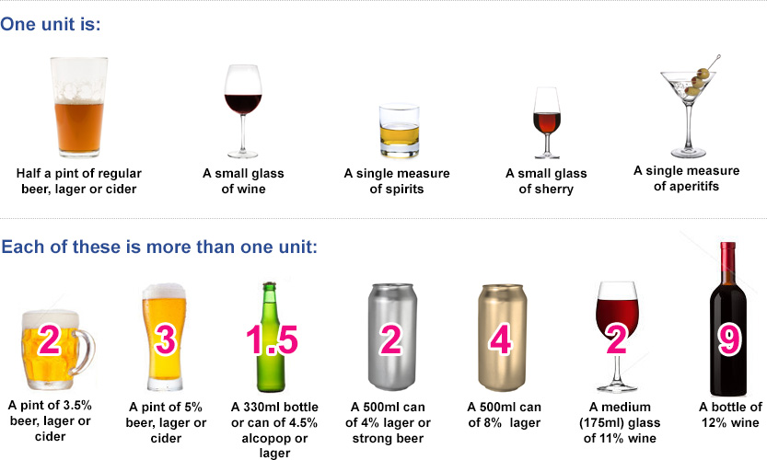

3. Your Lifestyle - Continued
Smoking
Do you smoke? | Never smoked | Ex-smoker | Yes
Do you use an e-Cigarette? | No | Ex-User | Yes
How many cigarettes did/do you smoke a day? | Less than one | 1-9 10-19 | 20-39 40+
Would you like help to quit smoking? | Yes | No
 | For further information, please see: www.nhs.uk/smokefree

Height & Weight
Height
Weight
Waist Circumference

Women Only
Do you use any contraception?  What is the name of your contraception?  If it is a coil or implant – can you please tell us when it was fit or when it is due for renewal | Yes No If needed, please book appointment.
Are you currently pregnant or think you may be? | Yes No Expected due date:

Students Only
Students are at risk of certain infections including mumps, meningitis and sexually transmitted infections, as well as mental health issues including stress, anxiety and depression. Please see Getting medical care as a student - NHS (www.nhs.uk)
I am less than 24 years old and have had two doses of the MMR Vaccination | Yes | No | Unsure
I am less than 25 years old and have had a Meningitis C Vaccination | Yes | No | Unsure

4. Further Details

Electronic Prescribing
If you would like your prescriptions to be sent electronically,  please provide details of the pharmacy you would like to use: | Pharmacy:

Patient Participation Group
Would you like to be involved in our Patient Participation Group? | Yes No
We are committed to improving the services we provide. The Patient Participation Group is a mechanism for us to gain valuable feedback from our patients about their experiences, views and ideas for improving our services.

Blood and Organ Donation
Note this section is optional for practice information only – to register for blood donation or opt out of organ donation go to:
Donate - NHS Blood and Transplant (nhsbt.nhs.uk) or Telephone: 0300 123 23 23 to speak to an advisor.

Blood Donation | I am already a blood donor  I do not wish to be a blood donor
Organ Donation | I am already registered as a donor  for all body parts  for these body parts:  I do not wish to be a donor

Signatures
Signature | I confirm that the information I have provided is true to the best of my knowledge.  Signed on behalf of patient
Name
Date

Checklist
Please ensure the form has been completed fully so that your registration can be processed

Completed & Signed this Form
Completed & Signed Supplementary Questions below (if not ordinarily resident in the UK)

Please provide the below if available

Photo Proof of ID e.g. Passport, Photo Driving License or Photo ID card
Proof of Address e.g. Bank statement, Utility Bill or Council Tax from within the last 3 months

Practice Use Only
Appointment | Required | Not Required
Photo ID | Passport | Driving licence | Identity card | Other
Proof of Address | Utility Bill | Council Tax | Bank Statement | Other
Supplementary Questions | Completed - see gms1-form-guidance-for-gp-practices.docx (live.com) for details on how to submit form

