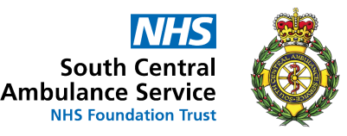

 .
Advance Booking Period
Using the online system, you can now book patients up to 7 days in advance of their journey.
Telephone bookings are restricted to 3 days as an advanced booking period

NEPTS
Online Bookings
https://pts.scas.nhs.uk/ptsonlinenew
COVID Status
We need to know the patient’s COVID status, this will either be confirmed/suspected or non COVID.
The patient and escort will also be required to wear a fluid repellent face mask unless exempt

What You Can Do Online
- Book transport (Excluding complex journeys)
- Check estimated time of arrivals
- Live message into the contact centre
- Amend/Cancel transport bookings

What You Will Need
- NHS Number
- Patient details including the GP practice
- Patient mobility
- Pick up location
- Drop off location
- Date & time of appointment


