  DOC-0108 / 26.05.22  Can I be involved?  Your LMC represents General Practice, now  and for the future. The strength of LMCs lies in representing the breadth of General Practice.  I would like to learn a bit more…  Send an e-mail to: office@wessexlmcs.org.uk  and we will try and arrange for you to attend  one of our meetings. They occur on Wednesday  afternoons (HIoW and Wilts) and Thursday  afternoons (Dorset) every couple of months.  We will put you in touch with a friendly mentor who will ensure you get the most from your attendance at the LMC meeting. Some of the acronyms and topics may be unfamiliar to you  to start with and a chat beforehand to  demystify the agenda can be helpful.  And then?  The representatives on the committees  are democratically elected. Stand for  election! |       The Management Team          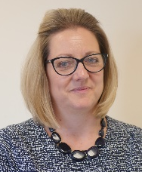      Dr Laura Edwards Joint CEO  Joint CEO  Acting CEO  Dawn Chalcraft  Assistant Director of Primary Care  Louise Greenwood  Director of  Wessex LEaD  Michelle Lombardi  Director  of Primary Care  Lisa Harding  Director  of Primary Care  Dr Will Howard  Medical Director  Dr Edd Rendall  Medical Director  Dr Andy Purbrick  Joint CEO  Wessex LMCs  Churchill House, 122-124 Hursley Road,  Chandler’s Ford, Eastleigh, Hampshire  SO53 1JB  Tel: 023 8025 3874  Web: www.wessexlmcs.com  DOC-0108 / 04.12.19 |   Representing:  - Dorset LMC  - Hampshire & Isle of Wight LMC  - BaNES, Swindon & Wiltshire LMC  Supporting:  - Jersey, Guernsey & Alderney GPs  What is an LMC?  A Guide for GPs
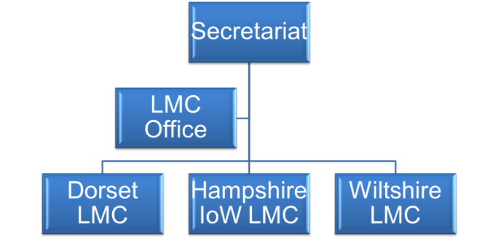  What is an LMC?  (Local Medical Committee)  The LMC is the only representative organisation mandated to represent and negotiate for GPs at a local level.  Each LMC is directly funded by GPs and are therefore politically independent. Each of the LMC committees comprises of democratically elected GPs who come together to highlight current issues in General Practice and feed back to their constituency. GPs who are  elected are paid an honoraria (fixed fee) and expenses for their time at committee meetings.  Wessex LMCs brings three representative  committees together. The Chairs and Vice Chairs of the committees are the governing body called the Secretariat.  The LMCs employ GPs to work on their  behalf and to be experts available on a day to day basis - representing the LMC at meetings and providing help and advice.  Our team comprises medical and  non-medical experts. |   Are LMCs the same as the  CCGs or the BMA?  ♦ LMCs are different to CCGs. CCGs are commissioning bodies, which means they are involved in designing, purchasing and monitoring patient care. They are membership organisations but CCGs are answerable to the government as well as GPs.  ♦ The BMA is the national voice of doctors and GPs. They negotiate on matters at a national level. They are a trade union which confers special legal connotations.  ♦ LMCs are advisers and are only answerable back to their GPs.  Who do LMCs meet and work with in representing GPs?  The LMC represent General Practice at a local level, which may involve working with NHS England, CCGs, RCGP, Health Education England or charities. The LMC can mediate where there is conflict or confusion and help engender mutual understanding. LMCs also offer other non-clinical services from expertise around disciplinary issues, contract changes to medico-legal issues, e.g. Data Protection Act interpretation and sometimes education and training.  The LMC are experts at the time when you can’t think of anyone else who would know the answer.  How do I get your services?  If you work as a GP partner, a salaried GP in a practice you will be covered by the practice  (who pay a levy). If you are a locum then you  need to pay a subscription of £50 annually by direct debit but for all local GP trainees we  offer the first year post qualification free. As  a Locum you can receive LMC emails free of  charge by forwarding your email address,  DOB, practice, title and area in which you  work, your GMC number and CCT date to: office@wessexlmcs.org.uk  On a day to day basis - what can the LMC do for you?  ♦ Useful e-mail updates – horizon scanning  ♦ Excellent website  ♦ Advice about contracts  ♦Premises advice  ♦ Interactions with hospitals  ♦ Partnership agreements or disagreements  ♦ Fee charging  ♦ Advice on GMS/ PMS contracts  ♦ Advice on registrations and deregistering  ♦ Complaints and disciplinary issues  ♦ Medical records – data sharing  ♦ Navigating appraisal and revalidation  ♦ Conferences and meetings  ♦ Wessex Insight  ♦Pensions  Ask the LMC when you don’t know  who to ask … | Are they the same thing as the CCGs or the BMA?  No. CCGs are different. They are commissioning bodies which mean they are involved in  designing, purchasing and monitoring patient care. They are membership organisations but CCGs are  answerable to the government as well as GPs. LMCs are advisers and are only answerable back to their GPs  The BMA is the national voice of doctors and GPs. They negotiate on matters at a national level. They are a trade union which confers special legal  connotations.  Who are LMCs representing GPs to?  They represent General Practice to everyone around GPs at a local level. That may be working with Area Teams, CCGs, RCGP, the LETB (Deanery) or charities. They can iron out misunderstandings and help engender mutual  understanding.  LMCs also offer other non-clinical services from expertise around disciplinary issues, contract changes to medico-legal issues e.g. Data Protection Act interpretation and sometimes education and training.  They are experts at the time when you can’t think of anyone else who would know the answer.  Are they the same thing as the CCGs or the BMA?  No. CCGs are different. They are commissioning bodies which mean they are involved in  designing, purchasing and monitoring patient care. They are membership organisations but CCGs are  answerable to the government as well as GPs. LMCs are advisers and are only answerable back to their GPs  The BMA is the national voice of doctors and GPs. They negotiate on matters at a national level. They are a trade union which confers special legal  connotations.  Who are LMCs representing GPs to?  They represent General Practice to everyone around GPs at a local level. That may be working with Area Teams, CCGs, RCGP, the LETB (Deanery) or charities. They can iron out misunderstandings and help engender mutual  understanding.  LMCs also offer other non-clinical services from expertise around disciplinary issues, contract changes to medico-legal issues e.g. Data Protection Act interpretation and sometimes education and training.  They are experts at the time when you can’t think of anyone else who would know the answer.  How do I get your services?  If you work as a GP partner, a salaried GP or as a trainee in a practice you will be covered by the practice (who pay a levy).  If you are a locum then you need to pay a subscription of £100 annually but for all local GP trainees we offer the first year post qualification free.  Locums can receive our e-mails free of charge  Send us your name, e-mail address,  GMC number and CCT date to  office@wessexlmcs.org.uk  Are they the same thing as the CCGs or the BMA?  No. CCGs are different. They are commissioning bodies which means they are involved in  designing, purchasing and monitoring patient care. They are membership organisations but CCGs are  answerable to the government as well as GPs. LMCs are advisers and are only answerable back to their GPs  The BMA is the national voice of doctors and GPs. They negotiate on matters at a national level. They are a trade union which confers special legal  connotations.  Who are LMCs representing GPs to?  They represent General Practice to everyone around GPs at a local level. That may be working with Area Teams, CCGs, RCGP, the LETB (Deanery) or charities. They can iron out misunderstandings and help engender mutual  understanding.  LMCs also offer other non-clinical services from expertise around disciplinary issues, contract changes to medico-legal issues e.g. Data Protection Act interpretation and sometimes education and training.  They are experts at the time when you can’t think of anyone else who would know the answer.  How do I get your services?  If you work as a GP partner, a salaried GP or as a trainee in a practice you will be covered by the practice (who pay a levy).  If you are a locum then you need to pay a subscription of £100 annually but for all local GP trainees we offer the first year post qualification free.  Locums can receive our e-mails free of charge  Send us your name, e-mail address,  GMC number and CCT date to  office@wessexlmcs.org.uk

