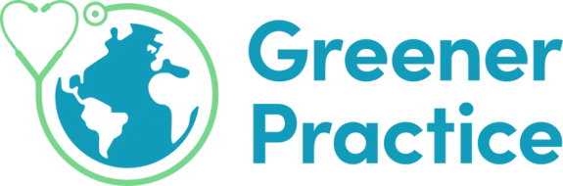

Greener Practice Bristol & Bath

Welcome to Greener Practice Bristol & Bath (GrPB). This document aims to give you an understanding of our group, the work it does and how you can get involved.

Greener Practice was created in Sheffield by a group of GPs who had become increasingly concerned about climate change and its impacts on health. The aim of Greener Practice is to help make primary care as sustainable and environmentally friendly as possible. The NHS is aiming to become the first net zero healthcare system in the world and Greener Practice hopes to help make this a reality.

There are now multiple local branches of Greener Practice all over the UK, including our Bristol & Bath group. We mainly cover the BNSSG area of Bristol, South Gloucestershire and North Somerset and the BSWCCG area of Bath, North East Somerset, Swindon and Wiltshire but anyone from further afield is also welcome. We are keen to include everyone who would like to get involved in this work, including GPs, allied healthcare professionals e.g., nurses, pharmacists, social prescribers, reception staff, administration staff and lay people. No prior experience or knowledge is necessary.

- Email greenerpractice@gmail.com to join the Greener Practice national email list
- Email greenerpracticebristol@gmail.com to join the Greener Practice Bristol & Bath (GrPB) group
- Join the GrPB WhatsApp group
- Join the GrPB Facebook group
- This Remedy page has lots of great links and resources for making your GP practice more environmentally sustainable
We meet via Zoom every 6-8 weeks to share learning and develop projects. Email greenerpracticebristol@gmail.com to find out the details of the next meeting.
The main areas we are focusing on currently are encouraging and helping GP practices to engage with the Green Impact for Health Toolkit, Planetary health Education and Awareness, Optimising sustainable respiratory prescribing and increasing Green Social prescribing. See here for a log of our work.

“We don’t need a handful of people doing zero waste perfectly;
we need everyone doing it imperfectly.”

